SECURE DATA TRANSMISSION IN CLOUD COMPUTING USING ENCRYPTION AND MACHINE LEARNING
Methodology, Novelty and Key Contributions
Department of Computer Science and Engineering, TKR College of Engineering & Technology
Batch A5 (CSE-A) · Academic year [ACADEMIC YEAR]
Table 1: Project team
S.No. | Student name | Roll number
1 | Avuti Sandhya | 23K91A0520
2 | Banothu Indu | 23K91A0530
3 | Dasari Sriteja | 23K91A0559
4 | Bejugam Vaishnavi | 23K91A0533

Project guide: CH. Prabhakar
Chapter and section numbers quoted in the text (for example Chapter 8 or Section 6.2) refer to the full project report, 17.Final Document. Figures and tables in this document are numbered from 1.

1. METHODOLOGY
This document describes how CipherGuard Shield works from end to end and what is new in it. Part 1 gives the pipeline, the data, the algorithms and the reasons they were chosen; Part 2 sets the work against the base paper and separates what is new from what is standard; Part 3 lists the contributions.

1.1 Overall methodology
CipherGuard Shield protects one cloud data path in two independent ways. The first protection is cryptographic: the payload is encrypted before it leaves the sender with a fresh key that only the cloud can reconstruct, and any change to the ciphertext is detected on arrival. The second is statistical: network-flow records that describe the traffic are scored by a machine-learning intrusion detector, and the flows judged to be attacks are logged with a severity. The idea of putting an intrusion detector and an elliptic-curve scheme in one framework comes from the base paper [1]; the project replaces its quantum-inspired network and custom elliptic-curve scheme with components that are standard, available in open-source libraries and testable on a laptop (Section 6.4 gives the reasons). The method has six steps, and the first two belong to the cryptographic lane and the next three to the detection lane:
1. Key agreement. For every message the sender generates a new P-256 key pair and combines its private key with the cloud's long-term public key (ECDH). The shared secret is passed through HKDF-SHA256 to give a 32-byte AES key.
2. Authenticated encryption. The payload is encrypted with AES-256-GCM under a random 12-byte nonce. The result is a ciphertext of the same length as the plaintext and a 16-byte authentication tag. The sender transmits the envelope: ciphertext, nonce, tag and its ephemeral public key.
3. Flow preparation. A flow record with 42 features is completed with defaults for missing fields and transformed by the fitted preprocessor: min-max scaling of the 39 numeric features and one-hot encoding of protocol, service and state.
4. Two classifiers. XGBoost and a one-dimensional convolutional network each output the probability that the flow is an attack.
5. Stacking and decision. A logistic-regression meta-model combines the two probabilities; a probability of at least 0.5 means attack, and the severity band (medium, high, critical) follows from the probability. Attacks are appended to an in-memory alert log.
6. Cloud verification. The cloud re-derives the AES key from its private key and the envelope's ephemeral public key, decrypts, and accepts the message only if the authentication tag verifies.
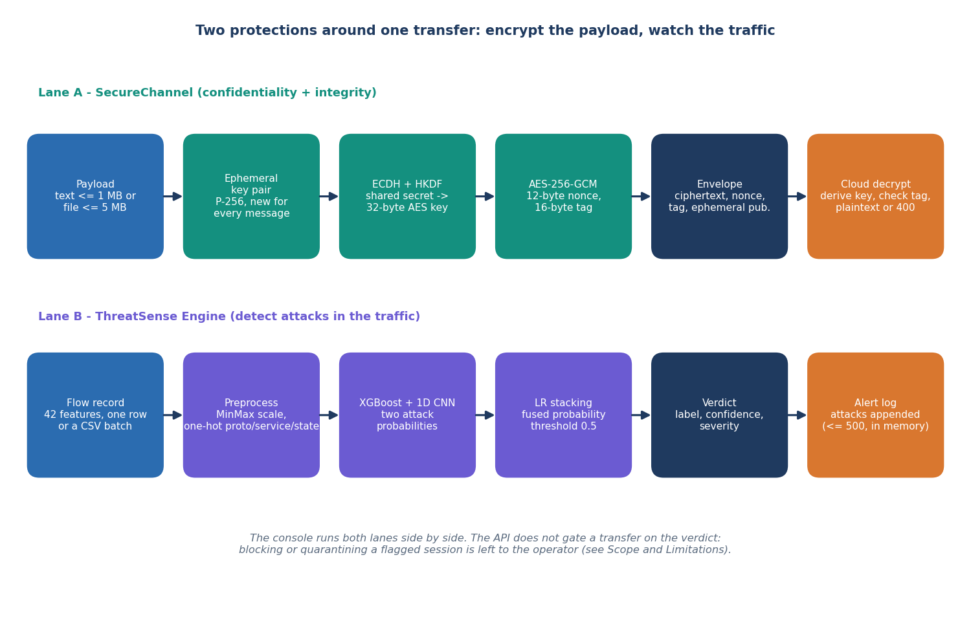
Figure 1: The two lanes of CipherGuard Shield: authenticated encryption of the payload and detection on the traffic.
Two procedures sit outside the request path. The training pipeline (cipherguard/ids/train.py) builds the shipped bundle once from a labelled table and writes the model files and reports/metrics.json. The experiment scripts added during the documentation run (scripts/run_experiments.py, benchmark_crypto.py, measure_pipeline.py) re-use the same preprocessing and model code to evaluate it on real data, to benchmark the cryptography and to time the whole pipeline. Their JSON output is the single source of every figure reported in this document.

1.2 Datasets
Three datasets are involved, and keeping them apart is essential for reading the results. The shipped model was trained on a synthetic table generated by the project; the experiments use real traffic from UNSW-NB15; and one experiment imitates the evaluation protocol of the base paper.

1.2.1 The synthetic demonstration dataset (shipped model)
When data/raw/ holds no UNSW-NB15 file, train_pipeline calls generate_synthetic (cipherguard/ids/synthetic.py) to create 12,000 rows: 6,000 normal and 6,000 attack, with the 42-feature schema of UNSW-NB15. The generator draws every numeric feature from a simple distribution whose parameters differ between the two classes. Attack flows get a longer duration (exponential with mean 1.8 s against 0.8 s), more source packets (Poisson with mean 18 plus a uniform 0 to 7 against Poisson 8), larger byte counts (log-normal with log-mean 7.2 against 6.3), a higher rate (normal with mean 45,000 against 18,000), more connection counters (ct_*) and a different mix of protocols, services and states. A few features are drawn independently of the class (window sizes, TCP base numbers, dttl), and ct_state_ttl is never assigned and is therefore 0 in every row.
After generation 2.5 % of the labels (300 of 12,000 rows) are flipped at random so that accuracy is not a perfect 1.0. The stratified 70/15/15 split gives 8,400 training, 1,800 validation and 1,800 test rows. The shipped metrics (accuracy 97.33%, F1 0.9733) are computed on that test split. Because the classes are separated by construction, the only thing that stops the model from reaching 100 % is the injected label noise, which caps accuracy at about 97.5 % if the clean classes were perfectly separable; the XGBoost model, the CNN and the stack all scored the same 97.33%, which is what a task this easy produces. A second consequence is that the attack_cat column of attack rows is drawn with an unseeded random call, so the file data/raw/synthetic_demo.csv is not reproducible bit for bit.

1.2.2 UNSW-NB15 (real traffic)
UNSW-NB15 [7, 8] was created at the Cyber Range Lab of UNSW Canberra by mixing real normal activity with synthetic contemporary attack behaviour generated by the IXIA PerfectStorm tool; 100 GB of raw traffic was captured with tcpdump, and the Argus and Bro-IDS tools and twelve further algorithms extracted flow features. The data is free for academic research with citation. This project uses the official partition: a training set of 175,341 flows (56,000 normal and 119,341 attack) and a testing set of 82,332 flows (37,000 normal and 45,332 attack, 55.06% attack). The ten traffic categories are Normal, Generic, Exploits, Fuzzers, DoS, Reconnaissance, Analysis, Backdoor, Shellcode and Worms. The 42 features used by the application are exactly the flow features of the official files; the files were obtained as the standard configuration of the Hugging Face repackaging lacg030175/UNSW-NB15 by scripts/fetch_unsw_nb15.py.
The two official files cover different capture periods, so a model trained on the first and tested on the second faces a temporal shift; accuracies obtained this way are lower than those from a random split of the same data, because near-duplicate flows cannot leak from the test set into training. The project reports the temporal protocol as its main real-data result for that reason.

1.2.3 The base paper's protocol
The base paper [1] evaluates on 9,000 flows of UNSW-NB15, balanced to 4,500 per class, split 70/15/15 and repeated ten times with averaged metrics; it does not publish which flows were drawn. The project imitates the protocol in run_paper: for each of ten seeds, 4,500 normal and 4,500 attack flows are sampled from the official training file and split into 6,300 training, 1,350 validation and 1,350 test flows. The sample is comparable in size and balance but not identical, so the comparison in Chapter 8 is indicative only.
Table 2: Datasets and splits used in this project.
Dataset | Rows | Role | Split
Synthetic demo CSV (generated) | 12,000 | Trains the shipped models | 8,400 / 1,800 / 1,800 (70/15/15)
UNSW-NB15 official training set | 175,341 | Trains the real-trained bundle | 149,039 fit / 26,302 validation (85/15)
UNSW-NB15 official testing set | 82,332 | Held-out test, never used for fitting | whole file
Paper-protocol sample | 9,000 | Imitates the base paper | 6,300 / 1,350 / 1,350, 10 repetitions

1.3 Data preparation and feature encoding
All three data paths use the same transformer, build_preprocessor() in cipherguard/ids/preprocessing.py. It is a scikit-learn ColumnTransformer [17] with two branches:
• a MinMaxScaler for the 39 numeric features (durations, packet and byte counts, rates, loads, jitter, TCP window and sequence fields, round-trip times, the ct_* connection counters and the three flag-like fields);
• a OneHotEncoder(handle_unknown="ignore") for the three categorical features proto, service and state, so that a category never seen in training produces an all-zero block instead of an error.
The encoded vector has 70 inputs for the synthetic bundle (39 numeric plus 31 one-hot columns: 6 protocols, 13 services, 12 states) and 192 inputs for the real-trained bundle, because the real files contain many more protocol values (for example unas, ospf, sctp) and service and state values. The scaler and the encoder are fitted on the training portion only; validation and test rows are only transformed, so no information from them reaches the fit.
At scoring time the engine is forgiving about the input. Missing feature columns are filled with 0 (numeric) or - (categorical); column names are matched case-insensitively; categorical values are cast to text; and the API merges a single record with documented defaults (for example proto tcp, service http, state CON). The identifier, label and attack_cat columns of a CSV are ignored when scoring. No further cleaning is applied to the real data; the files are used as published.
Class imbalance is handled in two ways. XGBoost receives scale_pos_weight = n_normal / n_attack computed on the training portion (about 0.47 for the real training file, close to 1 for the synthetic one). The README states that the CNN also uses balanced loss weighting; this is true only of the TensorFlow code path, which was not the one that ran. The PyTorch path, which produced every shipped and measured result, trains the CNN with plain, unweighted binary cross-entropy (Section 6.6).

1.4 Algorithm choice and justification
Each component was chosen for a reason that can be checked, and each rejected alternative has a reason too. Table 6.1 summarises the decisions and the paragraphs below discuss the three that matter most.
Table 3: Algorithm choices and the alternatives that were not used.
Role | Chosen | Not chosen | Reason
Payload cipher | AES-256-GCM [12, 15] | AES-CBC + HMAC; ChaCha20-Poly1305 | One primitive gives confidentiality and integrity; hardware-accelerated in the library; tag failure is a single, clear error
Key agreement | ECDH on P-256 [13] | RSA key transport (objective 1); finite-field DH | Small public values (65 B), a fresh key per message at almost no cost, no padding oracle surface
Key derivation | HKDF-SHA256 [14] | Use the raw shared secret | The ECDH output is not uniformly random; HKDF turns it into a uniform 256-bit key and binds a context string
Detector A | XGBoost [9] | Single decision tree; SVM | Strong on tabular data, trains in seconds, gives calibrated-enough probabilities, handles mixed scales
Detector B | 1D CNN [10] | LSTM; quantum-inspired network | Small (76 k parameters at 70 inputs), trains on CPU, offers a different inductive bias from trees
Fusion | Logistic-regression stacking [11] | Plain average; DSMMN score-level fusion | Two learned weights are easy to inspect and to report; the base paper's DSMMN needs parameters it does not publish

1.4.1 ECDH in place of RSA
The first batch objective asked for a hybrid scheme with AES for the payload and RSA for the key exchange. The project keeps the hybrid structure (an asymmetric step to establish a key, a symmetric cipher for the data) but uses elliptic-curve Diffie-Hellman for the asymmetric step. Two properties decided it. First, because the sender creates a fresh key pair for every message, compromise of one session key reveals nothing about other messages, which RSA key transport under a long-term key does not give. Second, the public value in the envelope is 65 bytes instead of the 256 bytes of an RSA-2048 wrapped key. The cost is that the cloud-side step is an ECDH computation (about 53 microseconds including HKDF on the measurement machine). To make the substitution testable, the project benchmarks RSA-2048 and RSA-3072 with OAEP [16] and AES-256-GCM on the same machine (Chapter 7): RSA encryption is cheaper (0.029 ms against 0.122 ms at 1 KB) but RSA decryption at the cloud is dearer (0.449 ms for RSA-2048 and 1.351 ms for RSA-3072 against 0.104 ms).

1.4.2 XGBoost and a CNN, stacked
The detector is deliberately a modest ensemble of two different learners. XGBoost is the strongest standard method on tabular flow features, and it is the model that carries the result on real data. The 1D CNN treats the encoded feature vector as a short sequence; it is included because the base paper's detector is also a convolutional one and because the brief asked for a deep model. The measurements in Chapter 8 show that on the official partition the CNN alone (accuracy 0.841 ± 0.004) is worse than XGBoost (0.910 ± 0.001) and that stacking (0.890 ± 0.002) does not recover the difference. The project reports this rather than adjusting the design: stacking improves slightly on a plain average of the two probabilities and costs almost nothing, but it is not better than XGBoost alone on this data.

1.4.3 What was not reproduced from the base paper
The base paper [1] proposes an eigenvalue-decomposition-augmented quantum-inspired network, a double-sigmoid median score-level fusion (DSMMN-SLF) and an enhanced elliptic-curve encryption (EECC) whose security the authors themselves say has not been proved against the ECDLP. None of these is implemented here. The quantum-inspired network is a research model without a maintained library, the fusion has parameters that are not published, and replacing a standard, reviewed cipher by a new scheme without a security proof would lower, not raise, the protection of real data. The project's contribution is therefore a clean, measured integration of standard parts, and Chapter 8 compares its numbers with the paper's with that difference stated.

1.5 Mathematical formulation
This section states the computations that the code performs, in the order of the pipeline. Symbols are defined where they first appear.

1.5.1 Key agreement, key derivation and authenticated encryption
Let G be the base point of NIST P-256 [13] and C = c·G the cloud's long-term public key, with private scalar c. For each message the sender draws a new scalar e and sends E = e·G. Both parties can compute the same shared point:
Z = x-coordinate of ( e · C ) = x-coordinate of ( c · E ) (1)
HKDF [14] with SHA-256 first extracts a pseudo-random key from Z (no salt, so a string of zero bytes is used) and then expands it with the context string cipherguard-shield-v1 to 32 bytes:
PRK = HMAC-SHA256( salt = 0^32 , Z ) K = HKDF-Expand( PRK , info = "cipherguard-shield-v1" , L = 32 ) (2)
AES-256-GCM [12] encrypts the plaintext M under K and a random 96-bit nonce N, producing a ciphertext T of the same length and a 128-bit tag A that authenticates T (and any associated data, here none):
( T , A ) = AES-256-GCM-Enc( K , N , M ) M = AES-256-GCM-Dec( K , N , T , A ) or reject (3)
GCM computes A from a polynomial (GHASH) over the ciphertext in the field GF(2^128), masked by an AES block that depends on the nonce. Changing any bit of T, N or A, or using a different K, changes the recomputed tag and the decryption fails with an invalid-tag error, which the API turns into HTTP 400. The envelope therefore adds 93 bytes to every message: 12 (nonce) + 16 (tag) + 65 (uncompressed ephemeral point) bytes.

1.5.2 Feature scaling and encoding
x' = ( x - min_j ) / ( max_j - min_j ) for each numeric feature j, with min_j and max_j taken from the training portion (4)
one-hot( v ) = ( 1[v = v_1] , ... , 1[v = v_m] ) an unseen v gives the zero vector (5)
Values outside the training range give scaled values below 0 or above 1; the models are not clipped. The result is the vector x of 70 (shipped) or 192 (real-trained) inputs.

1.5.3 The two classifiers
XGBoost [9] builds an additive model of regression trees. With the logistic loss, the probability of attack is
p_xgb( x ) = sigmoid( sum over t = 1..200 of f_t( x ) ) sigmoid( z ) = 1 / ( 1 + e^(-z) ) (6)
and each tree f_t is chosen to minimise a second-order approximation of the regularised objective
Obj = sum_i w_i · loss( y_i , yhat_i ) + sum_t ( gamma · T_t + 0.5 · lambda · ||leaf weights of tree t||^2 ) w_i = n_normal / n_attack for attack rows, else 1 (7)
where w_i is the scale_pos_weight re-weighting of the positive class. The depth is limited to 6, the learning rate is 0.08, and each tree sees 85 % of the rows and 85 % of the columns.
The 1D CNN reads x as a one-channel sequence of length d. With ReLU activations, max pooling of width 2 and convolutions padded so that the length is preserved:
h1 = ReLU( Conv1d_{1->32,k=3}( x ) ) , p1 = MaxPool2( h1 ) h2 = ReLU( Conv1d_{32->64,k=3}( p1 ) ) , p2 = MaxPool2( h2 ) (8)
u = ReLU( W1 · flatten( p2 ) + b1 ) , u' = Dropout_0.3( u ) p_cnn( x ) = sigmoid( W2 · u' + b2 ) (9)
The flattened vector has floor(d/4) × 64 elements: 1,088 for d = 70 and 3,072 for d = 192. The number of trainable parameters is 128 + 6,208 + (floor(d/4)·64 + 1)·64 + 65, which is 76,097 for the shipped bundle (file size about 300 KB) and 203,073 for the real-trained bundle. The network is trained by minimising the binary cross-entropy with the Adam optimiser [19]:
L = -( 1 / n ) · sum_i [ y_i · ln p_i + ( 1 - y_i ) · ln( 1 - p_i ) ] (10)

1.5.4 Stacking, decision rule and severity
The meta-model is a logistic regression [11] fitted on the validation split, whose inputs are the two base probabilities:
p( x ) = sigmoid( w_1 · p_xgb( x ) + w_2 · p_cnn( x ) + b ) (11)
The fitted values of the shipped bundle are w_1 = 3.767, w_2 = 3.585 and b = -3.573: both models contribute almost equally. The decision rule and the severity band are
label = attack if p >= 0.5 else normal severity = critical if p >= 0.85 , high if p >= 0.70 , medium otherwise (attacks only); normal flows are low (12)
A threshold of 0.5 is the shipped value. Chapter 8 shows how precision, recall and the false-positive rate move when it changes, because for an operator the cost of a false alarm and the cost of a missed attack are not equal.

1.5.5 Evaluation metrics
With TP, TN, FP and FN the counts of the confusion matrix in which attack is the positive class, the reported metrics are
accuracy = ( TP + TN ) / ( TP + TN + FP + FN ) precision = TP / ( TP + FP ) recall = TP / ( TP + FN ) F1 = 2 · precision · recall / ( precision + recall ) (13)
FPR = FP / ( FP + TN ) FNR = FN / ( FN + TP ) MCC = ( TP·TN - FP·FN ) / sqrt( ( TP+FP )( TP+FN )( TN+FP )( TN+FN ) ) (14)
ROC-AUC is the area under the curve of recall against FPR over all thresholds. When several seeds are run the tables report the mean and the sample standard deviation (n - 1 in the denominator).

1.6 Model architecture and training
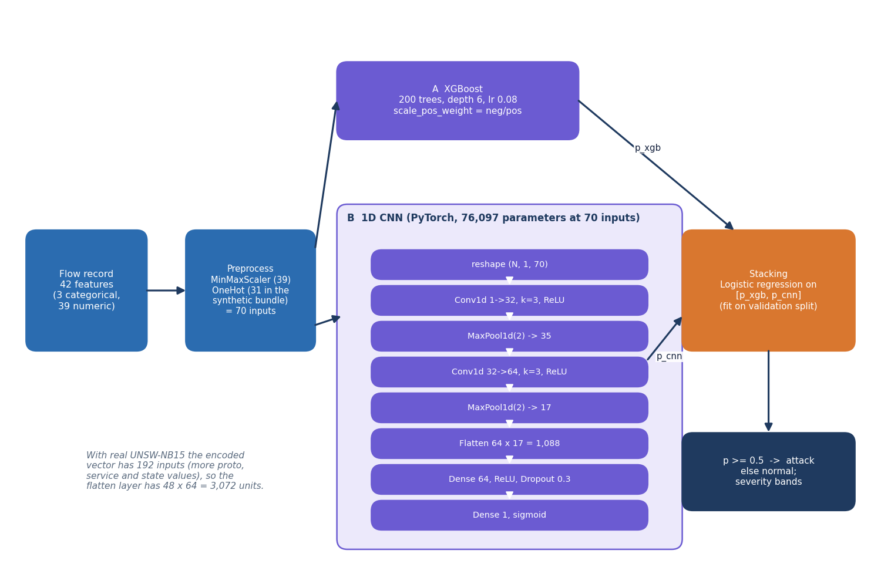
Figure 2: Architecture of the ThreatSense Engine: preprocessing, XGBoost, the 1D CNN and the stacking meta-model.

1.6.1 Training configuration
Table 4: Training configuration shared by the shipped bundle and the experiments.
Component | Setting
XGBoost | 200 trees, max depth 6, learning rate 0.08, subsample 0.85, column sample 0.85, scale_pos_weight = n_normal / n_attack, logloss, seed from the run
1D CNN | Conv1d 1-32 (k 3) - MaxPool 2 - Conv1d 32-64 (k 3) - MaxPool 2 - Linear 64 - Dropout 0.3 - Linear 1 - sigmoid; 76,097 parameters at 70 inputs
CNN training | Adam, learning rate 0.001, batch 256, at most 15 epochs, early stopping on validation loss (patience 5, minimum gain 0.0001), best weights restored, plain BCE loss (no class weights)
Meta-model | scikit-learn LogisticRegression with default regularisation, fitted on the validation split's [p_xgb, p_cnn]
Split | Stratified; shipped: 70/15/15 (seed 42); official partition: training file split 85/15 into fit and validation, testing file untouched
Decision | Threshold 0.5 on the stacked probability
Hardware | Intel Core i5-12500 (6 cores / 12 threads), 15.7 GB RAM, Windows 11, CPU only; Python 3.11.9, PyTorch 2.14.1 (CPU), XGBoost 2.0.3, scikit-learn 1.5.0

Training is cheap. On the official partition (149,039 fit rows) XGBoost trains in 4.4 s and the CNN in 246 s on the shared CPU used for the measurements; the meta-model takes milliseconds. The README gives 30 to 60 seconds for building the shipped bundle from the synthetic table, which is what run.bat does on first start when models/ is empty.

1.6.2 Experimental protocol
The experiment script scripts/run_experiments.py imports the shipped code rather than re-implementing it: the preprocessor, the XGBoost settings, train_cnn_torch and the logistic meta-model are the same objects. For the official partition it runs five seeds (42 to 46). A seed controls the stratified 85/15 split of the training file and the initialisation of the CNN and XGBoost; the official testing file (82,332 flows) is scored once per seed and never used for fitting, early stopping or the meta-model. Besides the three project models the script trains four reference models on the same data, so that the ensemble can be judged against simpler alternatives: the plain mean of the two probabilities, a logistic regression, a decision tree (depth 12) and a random forest (100 trees, depth 16). For seed 42 it additionally records the threshold sweep, the detection rate per attack category, the ROC curves, the XGBoost feature importance (gain) and in-process inference times.
For the paper protocol it repeats the whole procedure for ten seeds on the balanced 9,000-flow samples described in Section 6.2.3. For the domain-shift study it scores the 82,332 real test flows with the shipped synthetic-trained bundle, scores fresh synthetic data (seed 7, 6,000 rows) with the same bundle, and scores the synthetic demo CSV with the real-trained models. The seed-42 models are also exported as a bundle that the API can serve (scripts/make_real_bundle.py, Section 6.10).
The measured outcome of the protocol is summarised in one line here so that the design can be read against it. On the official partition the stacked model reaches accuracy 0.890 ± 0.002, F1 0.907 ± 0.001 and ROC-AUC 0.984 ± 0.000 (seed 42: 28,646 true negatives, 8,354 false positives, 877 false negatives, 44,455 true positives); at a threshold of 0.9 the accuracy rises to 0.921 and the false-positive rate falls to 0.096. The shipped synthetic-trained bundle, by contrast, scores 0.660 on the same real flows. Chapter 8 discusses both.

1.6.3 Two implementation details that affect interpretation
• Unweighted CNN loss. The README describes balanced loss weighting for the CNN. The PyTorch training function uses nn.BCELoss() with no weights; the weighted loss exists only in the TensorFlow function. On the real data this probably contributes to the CNN's high recall (0.99) and high false-positive rate, because the majority class in the training file is attack.
• Stacking on the validation split. The meta-model is fitted on 15 % of the training period. It therefore learns how well the two models agree with the labels in that period; on the later testing period the CNN is less reliable than the weights suggest, which is why the stack is not better than XGBoost alone on the official partition.

2. NOVELTY AGAINST THE BASE PAPER

2.1 What the base paper contributes
The base paper [1] proposes a detection model that fuses a quantum-inspired convolutional network with a flatten-layer feature map and an eigenvalue-decomposition block (FLPF with EVD-QNN) and a LeNet classifier through a double-sigmoid, median-normalised score-level fusion (DSMMN-SLF), and an enhanced elliptic-curve scheme (EECC) that encrypts data judged free of intrusion. It evaluates on 9,000 balanced UNSW-NB15 samples and reports a mean accuracy of 0.9487, a precision of 0.97 and an encryption time of 0.39 s. Its own text admits the limits: the quantum network is quantum-inspired and runs on classical hardware, the EECC has no proof of security under the elliptic-curve discrete-logarithm assumption, and the data set is balanced and small.

2.2 What is new in this project and what is not
Table 5: Novelty against the base paper
Aspect | Base paper | This project | New?
Detection algorithm | FLPF-EVD-QNN + LeNet, DSMMN-SLF fusion | XGBoost + 1D CNN, logistic-regression stacking | No - standard methods, chosen for transparency and low cost
Encryption algorithm | EECC (non-standard, unproven) | ECDH P-256 + HKDF-SHA256 + AES-256-GCM, standard primitives from a maintained library | No - but a deliberate, defensible substitution
Key handling | Static key relations in the scheme | Fresh ephemeral key pair per message, forward secrecy per message, 93-byte fixed envelope | Design choice that differs
Running system | Offline simulation | Working service: REST API, React console, alert log, tamper test, file mode | Yes
Combined overhead | Detection and encryption timed separately | One protected transfer measured end to end: 5.7 ms in process, 8.1 ms over HTTP | Yes
Baseline for the key exchange | AES, ElGamal, Blowfish, ECC, RSA compared on abstract timing | RSA-2048/3072-OAEP + AES-GCM benchmarked on the same machine, by payload size | Yes, as a measurement
Training-data audit | Balanced 9,000-sample subset | Synthetic bundle exposed: 0.9733 on synthetic data against 0.660 on real flows; real-data experiments on the official partition | Yes
Evaluation protocol | 10 runs on a random balanced subset | Both that protocol and the official temporally split partition, 5 seeds, thresholds, categories | Yes

2.3 Why the integration counts
The literature survey of this batch found one gap: cryptography and intrusion detection are treated as separate concerns, and nobody measures what the pair costs on one transmission path. CipherGuard Shield places both behind one API and one console and measures the pair. The result is not what one would assume: detection accounts for 81% of the per-transfer cost and encryption plus decryption for 19%, so the cheap, standard cipher can be switched on for every message and the budget question is the detector.
A second contribution is negative and therefore easy to overlook: the project shows, with the same code, that a model can score 97.33% on the data it was built for and 66% on real traffic, and that a stacked ensemble can be no better than its strongest member. Reporting these results is part of the method, not an afterthought.

2.4 Where this work is weaker than the base paper
• No quantum-inspired network, no DSMMN fusion and no EECC were reproduced; the comparison with the paper is therefore a comparison of outcomes under a similar protocol, not of methods.
• On the comparable protocol the stacked model reaches 0.938 ± 0.007 accuracy against the paper's 0.9487, and 0.934 ± 0.012 precision against 0.97.
• The paper reports attack analyses (brute force, chosen-ciphertext, man-in-the-middle) for its scheme; here only integrity and uniqueness tests were run, and the strength of AES-GCM and P-256 rests on the standards.

3. KEY CONTRIBUTIONS
The work makes the following contributions.
1. A working secure-transmission platform. SecureChannel encrypts text or files up to 5 MB with ECDH P-256, HKDF-SHA256 and AES-256-GCM using a fresh ephemeral key per message, with tag verification at the cloud and a one-click tamper test.
2. An intrusion detector with an alert log and a live console. The ThreatSense Engine stacks XGBoost and a 1D CNN, returns a label, a confidence and a severity, and appends attacks to an alert list shown in a React console.
3. A measured combined overhead. One protected 100 KB transfer costs 5.7 ms in process (81% detection, 11% encryption, 8% decryption) and 8.1 ms as three HTTP calls, closing the gap named by the literature survey.
4. A cryptographic baseline comparison. RSA-2048 and RSA-3072 OAEP hybrids were benchmarked against SecureChannel: RSA wraps a key faster (0.03 ms against 0.12 ms at 1 KB) but unwraps it slower (0.45 and 1.35 ms against 0.10 ms), and 1,000 trials of each of six tamper cases were all handled correctly.
5. Detection results on real data with an honest protocol. On the official UNSW-NB15 partition the stacked model reaches 0.890 ± 0.002 accuracy and XGBoost alone 0.910 ± 0.001; the base paper's protocol gives 0.938 ± 0.007; thresholds, categories and seeds are reported.
6. An audit of the synthetic default. The shipped 0.9733 accuracy is explained (2.5% label noise cap, three models identical) and contrasted with 0.660 on real flows; a real-trained bundle can be served with two environment variables.
7. Reproducible tooling. Scripts for data fetching, experiments, crypto benchmarks, pipeline latency, screenshots, 26 automated tests and 15 smoke checks, with every figure in the documents generated from stored JSON.
None of these contributions is a new algorithm; they are engineering, measurement and honest reporting around standard components.

